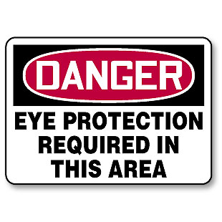
Semper Safe
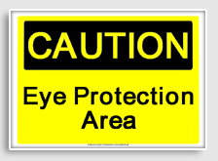
Set your sights on eye safety!
Our sense of sight is probably our most critical faculty and without full use of it our lives can be dramatically altered. Yet, every year according to the latest Bureau of Labor Statistics there are 42,286 occupational injuries or illnesses involving the eye resulting in days away from work. What’s worse, it is estimated that nearly 90% of these injuries could be avoided by simply wearing appropriate eye protection. Not wearing suitable eye protection is the single biggest contributor to eye injuries in the workplace, at home, or during sporting activities.

The typical eye injuries occur by rubbed or abraded foreign matter, such as metal chips, dirt particles, and splinters, or by striking the eye; surface wounds, such as abrasions, scratches are among the most common types of injuries to the eyes. Young and old alike are afflicted and accidental eye impairment shows no particular affinity toward who is next to be injured. We all share equally in the chance of being hurt if we do not take the adequate precautions as listed below and adhere to the simple tips to help assist in preventing eye injury mishaps at work and home.

Common Work Hazards:
- Dust, concrete, metal shavings, wool fiber and other flying particles.
- Falling or shifting debris, building materials and glass.
- Chemicals (acids, bases, fuels, solvents, lime, wet or dry cement powder).
- Intense light created by welding arcs and lasers.
- Smoke and noxious or poisonous gases.
- Molten metal, thermal hazards and fires.
- Blood and other infectious bodily fluids.

Injury Prevention Tips:
- Know and obey established MCO and your Command safety precautions concerning eye safety.
- Be alert for eye hazards - know that injuries can occur at anytime at work or home.
- Wear effective eye protection that is appropriately designed for the task or activity at hand.
- Ensure protective eyewear is clean and serviceable. Replace faulty or broken eye protection.
- Wear specifically designed eye protection; review units most recent Industrial Hygiene Survey.
- Wear sunglasses that block 99% - 100% of the ultraviolet A and B rays when outdoors.
- Exercise caution with common cleaning chemicals - many can cause serious eye damage.
- Never mow the lawn or use a grass/weed trimming device without proper safety goggles.
- Utilize the appropriate sports eye-guard, safety goggles, or face mask/shield the specific activity.
- Know basic eye injury first-aid and seek medical attention immediately in the event of an injury.

Commanders and Supervisors: It is your responsibility to ensure that your personnel working in eye-hazardous areas or operations are provided adequate eye protection and at the organizations expense. To assist you in your duties, a “Leaders Guide” is provided on the following page. For more information contact your Unit Safety Officer, Base Safety Representative or visit our website; https://intranet.mcieast.usmc.mil/C12/Workplace%20Safety%20Information%20S/default.aspx.

As Marines, Sailors and Civil Servants we live by our ethos. So think before you jeopardize the safety of yourself, your fellow Marines, Sailors, civilian employees or
family members, and remember SEMPER SAFE!
SS 08-11

LEADERS GUIDE
Semper Safe 08-11, Workplace Eye Safety
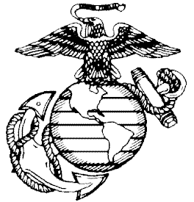
Situation: Marines, Sailors and government employees working in eye-hazardous areas or operations identified in their PPE or Industrial Hygeine (IH) survey shall be provided adequate eye protection at organizational expense. All persons entering an eye-hazardous area or a hazard radius of an eye-hazardous operation, including supervisors or visitors, must wear eye protection.

Mission: To safeguard personnel from eye injuries by providing protective eye wear.

Execution: Determine if there is a requirement for your personnel to wear protective eyewear:

(1) Conduct a hazard assessment of your operations to determine if hazards are, or are likely to be, present which necessitate use of protective eyewear. This can also be accomplished by reviewing the most recent Industrial Hygiene (IH) Survey or PPE Survey.
(2) Provide to each affected employee eye protection appropriate for the eye hazards that they are exposed to. This includes prescription safety eyewear or eye protection that can be worn over the prescription lenses without disturbing the proper position of the prescription lenses/protection. .
(3) Ensure personnel are properly trained on how to correctly wear, maintain and inspect eyewear.

(4) Post warning signs with "EYE HAZARD-WHILE EQUIPMENT OPERATING" at entrances and inside eye hazardous areas. Place warning decals or signs with "WEAR GOGGLES WHILE OPERATING THIS MACHINE" on equipment involving eye hazardous operations.

(5) The DoN pays for the prescription safety glasses of government employees, not the exams.

(6) To enroll new civilian employees into the Sight Conservation Program, the employee must work in an eye hazardous area greater than 50 percent of their workday and whose unaided visual skills do not meet the requirements of his or her job. The employee also must provide a copy of his or her current optical prescription.

(7) The employee's Unit Safety Officer (USO) or supervisor submits a written request to Base Safety with the employee's name, DOB, last 4 SSN, Job Title, and Organization.

(8) The program works on a two year cycle. Base Safety notifies the USO and/or Supervisor via email with the names of employees that are approaching their two year renewal date. Base Safety will prepare the paperwork and then notify the USO or Supervisor and employee that the
Paperwork is ready for pick up. The Base Safety POC is Mrs. Frann Dickerson at 451-5725.

Administration and Logistics: Maintain copies of PPE Surveys and IH Surveys as part of your Safety Program. Ensure that an adequate supply of required protective eyewear is available.

Command and Control: Establish in your Safety Program procedures to ensure protective eyewear is available and used properly. Conduct spot inspections for proper use and serviceability.

References:
- NAVMC DIR 5100.8, Chapter 13, Paragraph 13007, Eye Protection
- ANSI Z87.1-2003, Occupational Personal Eye Protection Devices
- CFR 1910.133, Eye and Face Protection SS 08-11

